PF LAB 06:

Task 1:  
Code:

#include <iostream>

#include <fstream>

using namespace std;

*fstream* file;

void write(int *average*){

    file.open("Status.txt", *ios*::out);

    if (file.is_open()){

        if (*average* < 4){

        file << "Below average";

    }

    else if (*average* >= 4 && *average* <= 6){

        file << "On average";

    }

    else if (*average*>6){

        file << "Above Average";

    }

    }

    else{

        cout<<"Error opening Status.txt"<<endl;

    }

}

int read(){

    int average;

    file.open("average.txt", *ios*::in);

    if(file.is_open()){

        file >> average;

    file.close();

    return average;

    }

    else{

        cout<<"Error opening average.txt"<<endl;

    }

}

int main(){

    int average = read();

    write(average);

    return 0;

}

FILE:  
average.txt:

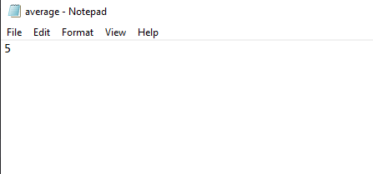  
Status.txt:

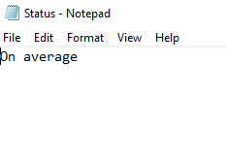

Task 2:

Code:

#include <iostream>

using namespace std;

float addition(float *fvalue*, float *svalue*){

    return *fvalue* + *svalue*;

}

float subtraction(float *fvalue*, float *svalue*){

    return *fvalue* - *svalue*;

}

float multiplication(float *fvalue*, float *svalue*){

    return *fvalue* * *svalue*;

}

float division(float *fvalue*, float *svalue*){

    return *fvalue* / *svalue*;

}

float calculator(float *fvalue*,float *svalue*, char *option*){

    if (*option* == '*'){

        return multiplication(*fvalue*, *svalue*);

    }

    else if (*option* == '+'){

        return addition(*fvalue*, *svalue*);

    }

    else if (*option* == '-'){

        return subtraction(*fvalue*, *svalue*);

    }

    else if (*option* == '/'){

        return division(*fvalue*, *svalue*);

    }

}

int main(){

    float first_value;

    float second_value;

    char option;

    cout << "enter the first value : "<<endl;

    cin >> first_value;

    cout << "Enter the second value : "<<endl;

    cin >> second_value;

    cout << "Enter the operation : "<<endl;

    cin >> option;

    float answer = calculator(first_value, second_value, option);

    cout << answer;

    return 0;

}

OUTPUT:

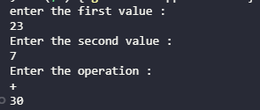

Task 3:  
Code:

#include <iostream>

using namespace std;

float addition(float *fvalue*, float *svalue*){

    return *fvalue* + *svalue*;

}

float subtraction(float *fvalue*, float *svalue*){

    return *fvalue* - *svalue*;

}

float multiplication(float *fvalue*, float *svalue*){

    return *fvalue* * *svalue*;

}

float division(float *fvalue*, float *svalue*){

    return *fvalue* / *svalue*;

}

int main(){

    float first_value;

    float second_value;

    cout << "enter the first value : " << endl;

    cin >> first_value;

    cout << "Enter the second value : " << endl;

    cin >> second_value;

    char option;

    cout << "Press '+' for addition \n";

    cout << "Press '-' for subtraction \n";

    cout << "Press '*' for multiplication \n";

    cout << "Press '/' for division \n";

    cout << "Enter the option : ";

    cin >> option;

    if (option == '*'){

        cout<<multiplication(first_value, second_value);

    }

    else if (option == '+'){

        cout<<addition(first_value, second_value);

    }

    else if (option == '-'){

        cout<<subtraction(first_value, second_value);

    }

    else if (option == '/'){

        cout<<division(first_value, second_value);

    }

    return 0;

}

OUTPUT:

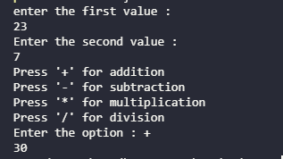

Task 4:

Code :

#include <iostream>

using namespace std;

void days(int *number*){

    switch (*number*) {

    case 1:

        cout << "Monday";

        break;

    case 2:

        cout << "Tuesday";

        break;

    case 3:

        cout << "Wednesday";

        break;

    case 4:

        cout << "Thursday";

        break;

    case 5:

        cout << "Friday";

        break;

    case 6:

        cout << "Saturday";

        break;

    case 7:

        cout << "Sunday";

        break;

    }

}

int main(){

    int number;

    cout << "Enter a number : ";

    cin >> number;

    days(number);

    return 0;

}

OUTPUT:  


Task 5:

Code:

#include <iostream>

using namespace std;

void operation( int *array*[] , int *size*, int *option*){

    if (*option* == 1){

        int swap;

        for (int i = 0; i < *size*; i++)

        {

            for (int j = 0; j < *size*; j++)

            {

                if (*array*[i]<*array*[j]){

                    swap = *array*[j];

*array*[j] = *array*[i];

*array*[i] = swap;

                }

            }

        }

        for (int i = 0; i < *size*; i++)

        {

            cout << *array*[i]<<" ";

        }

    }

    if (*option* == 2){

        int swap;

        for (int i = 0; i < *size*; i++)

        {

            for (int j = 0; j < *size*; j++)

            {

                if (*array*[i]>*array*[j]){

                    swap = *array*[j];

*array*[j] = *array*[i];

*array*[i] = swap;

                }

            }

        }

        for (int i = 0; i < *size*; i++)

        {

            cout << *array*[i]<<" ";

        }

    }

}

int main(){

    int arr[10] = { 10, 6, 4, 3, 5, 7, 8, 9, 1, 2 };

    int option;

    int size = sizeof(arr) / sizeof(arr[0]);

    cout << "Press 1 for ascending\nPress 2 for descending : ";

    cin >> option;

    operation(arr,size,option);

}

OUTPUT:





Task 6:

Code:

#include <iostream>

using namespace std;

float calulator_average(float *f*,float *s*,float *t*){

    float average;

    float sum;

    sum = *f*+*s*+*t*;

    average = sum/3;

    return average;

}

int main(){

    float number1;

    float number2;

    float number3;

    cout << "Enter the first number : ";

    cin >> number1;

    cout<<"Enter the second number : ";

    cin >> number2;

    cout<<"Enter the third value : ";

    cin >> number3;

    cout<<calulator_average(number1,number2,number3)<<endl;

}

OUTPUT:  
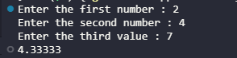

Task 7:

Code:

#include <iostream>

using namespace std;

float max(float *num1*,float *num2*){

    if(*num1*>*num2*){

        return *num1*;

    }

    else if(*num1*<*num2*){

        return *num2*;

    }

    else{

        cout<<"Both are equal"<<endl;

    }

}

int main(){

    float number1,number2;

    cout<<"Enter the first number : ";

    cin>>number1;

    cout<<"Enter the second number : ";

    cin>>number2;

    cout<<"Maximum number is : "<<max(number1,number2);

}

OUTPUT:



Task 8

Code:

#include <iostream>

using namespace std;

float swap(float &*num1*,float &*num2*){

    int swap = *num1*;

*num1* = *num2*;

*num2* = swap;

}

int main(){

    float num1,num2;

    cout<<"Enter the first number : ";

    cin>>num1;

    cout<<"Enter the second number : ";

    cin>>num2;

    cout<<"Before swapping\n";

    cout<<"num1 : "<<num1<<endl;

    cout<<"num2 : "<<num2<<endl;

    swap(num1,num2);

    cout<<"After swapping\n";

    cout<<"num1 : "<<num1<<endl;

    cout<<"num2 : "<<num2<<endl;

}

Output:

